Physics 104 Assignment 21

21.8. Identify: Use the mass of a sphere and the atomic mass of aluminum to find the number of aluminum atoms in one sphere. Each atom has 13 electrons. Apply Coulomb’s law and calculate the magnitude of charge on each sphere.
Set Up: where is the number of electrons removed from one sphere and added to the other.
Execute: (a) The total number of electrons on each sphere equals the number of protons.
(b) For a force of N to act between the spheres, . This gives The number of electrons removed from one sphere and added to the other is
(c)
Evaluate: When ordinary objects receive a net charge the fractional change in the total number of electrons in the object is very small.
21.9. Identify: Apply Coulomb’s law.
Set Up: Consider the force on one of the spheres.
(a) Execute:
so
(b)
so
And then
Evaluate: The force on one sphere is the same magnitude as the force on the other sphere, whether the spheres have equal charges or not.
21.15. Identify: Apply Coulomb’s law. The two forces on must have equal magnitudes and opposite directions.
Set Up: Like charges repel and unlike charges attract.
Execute: The force that exerts on has magnitude and is in the +x-direction.
must be in the −x-direction, so must be positive. gives .
Evaluate: The result for the magnitude of doesn’t depend on the magnitude of
21.17. Identify: Apply Coulomb’s law and find the vector sum of the two forces on
Set Up: Like charges repel and unlike charges attract, so and are both in the
Execute: and is in the
Evaluate: Comparing our results to those in Example 21.3, we see that as required by Newton’s third law.
21.21. Identify: Apply Coulomb’s law to calculate the force each of the two charges exerts on the third charge. Add these forces as vectors.
Set Up: The three charges are placed as shown in Figure 21.21a.

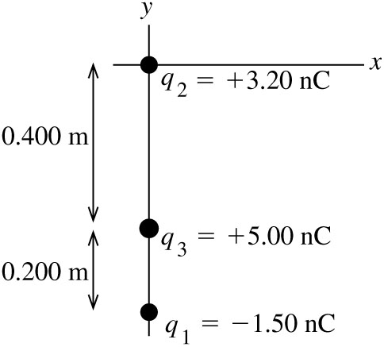
Figure 21.21a

Execute: Like charges repel and unlike attract, so the free-body diagram for is as shown in
Figure 21.21b.
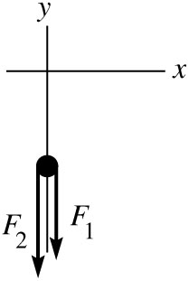
Figure 21.21b
The resultant force is
The resultant force has magnitude and is in the
Evaluate: The force between is attractive and the force between is replusive.
21.25. Identify: Since the field is uniform, the force and acceleration are constant and we can use a constant acceleration equation to find the final speed.
Set Up: A proton has charge +e and mass
Execute: (a)
(b)
(c) gives
Evaluate: The acceleration is very large and the gravity force on the proton can be ignored.
21.29. (a) Identify: Eq. (21.4) relates the electric field, charge of the particle, and the force on the particle. If the particle is to remain stationary the net force on it must be zero.
Set Up: The free-body diagram for the particle is sketched in Figure 21.29. The weight is mg, downward. For the net force to be zero the force exerted by the electric field must be upward. The electric field is downward. Since the electric field and the electric force are in opposite directions the charge of the particle is negative.

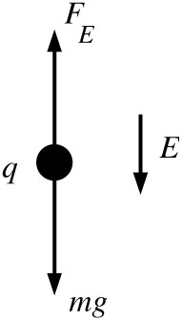
Figure 21.29
Execute:
(b) Set Up: The electrical force has magnitude The weight of a proton is so
Execute:
This is a very small electric field.
Evaluate: In both cases In part (b) the ratio is much smaller than in part (a) so E is much smaller in (b). For subatomic particles gravity can usually be ignored compared to electric forces.
21.31. Identify: For a point charge, The net field is the vector sum of the fields produced by each charge. A charge q in an electric field experiences a force
Set Up: The electric field of a negative charge is directed toward the charge. Point A is 0.100 m from and 0.150 m from Point B is 0.100 m from and 0.350 m from
Execute: (a) The electric fields at point A due to the charges are shown in Figure 21.31a.
Since the two fields are in opposite directions, we subtract their magnitudes to find the net field. to the right.
(b) The electric fields at point B are shown in Figure 21.31b.
Since the fields are in the same direction, we add their magnitudes to find the net field. to the right.
(c) At A, to the right. The force on a proton placed at this point would be to the right.
Evaluate: A proton has positive charge so the force that an electric field exerts on it is in the same direction as the field.
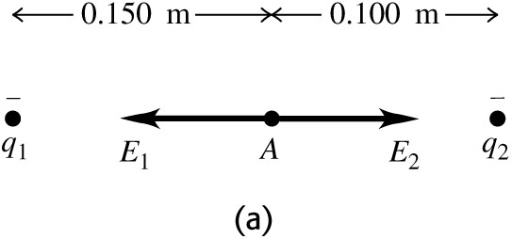 |  | 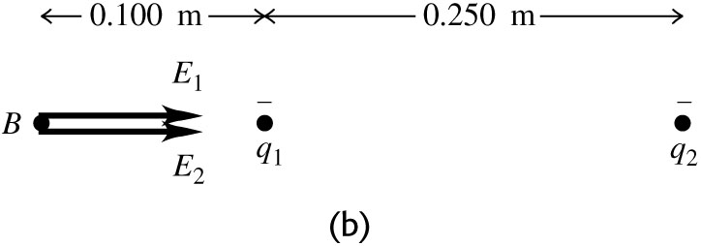
Figure 21.31
21.32. Identify: The electric force is
Set Up: The gravity force (weight) has magnitude and is downward.
Execute: (a) To balance the weight the electric force must be upward. The electric field is downward,
so for an upward force the charge q of the person must be negative. gives and
(b) The repulsive force is immense and this is not a feasible means of flight.
Evaluate: The net charge of charged objects is typically much less than 1 C.
21.33. Identify: Eq. (21.3) gives the force on the particle in terms of its charge and the electric field between the plates. The force is constant and produces a constant acceleration. The motion is similar to projectile motion; use constant acceleration equations for the horizontal and vertical components of the motion.
(a) Set Up: The motion is sketched in Figure 21.33a.

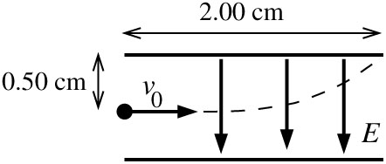 |  | For an electron
Figure 21.33a

negative gives that and are in opposite directions, so is upward. The free-body diagram for the electron is given in Figure 21.33b.

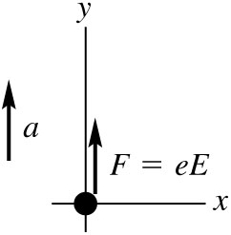 |  | Execute:
Figure 21.33b

Solve the kinematics to find the acceleration of the electron: Just misses upper plate says that when
x-component
In this same time t the electron travels 0.0050 m vertically:
y-component
(This analysis is very similar to that used in Chapter 3 for projectile motion, except that here the acceleration is upward rather than downward.) This acceleration must be produced by the electric-field force:
Note that the acceleration produced by the electric field is much larger than g, the acceleration produced by gravity, so it is perfectly ok to neglect the gravity force on the elctron in this problem.
(b)
This is much less than the acceleration of the electron in part (a) so the vertical deflection is less and the
proton won’t hit the plates. The proton has the same initial speed, so the proton takes the same time to travel horizontally the length of the plates. The force on the proton is downward (in the
same direction as since q is positive), so the acceleration is downward and The displacement is downward.
(c) Evaluate: The displacements are in opposite directions because the electron has negative charge and the proton has positive charge. The electron and proton have the same magnitude of charge, so the force the electric field exerts has the same magnitude for each charge. But the proton has a mass larger by a factor of 1836 so its acceleration and its vertical displacement are smaller by this factor.
(d) In each case and it is reasonable to ignore the effects of gravity.
21.39. Identify: Find the angle that makes with the +x-axis. Then .
Set Up:
Execute: (a)
(b)
(c) (Second quadrant).
Evaluate: In each case we can verify that is a unit vector, because
21.45. Identify: Eq. (21.7) gives the electric field of each point charge. Use the principle of superposition and add the electric field vectors. In part (b) use Eq. (21.3) to calculate the force, using the electric field calculated in part (a).
(a) Set Up: The placement of charges is sketched in Figure 21.45a.

\
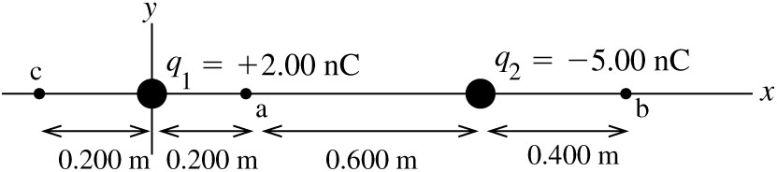
Figure 21.45a
The electric field of a point charge is directed away from the point charge if the charge is positive and toward the point charge if the charge is negative. The magnitude of the electric field is where r is the distance between the point where the field is calculated and the point charge.
- At point a the fields are directed as shown in Figure 21.45b.

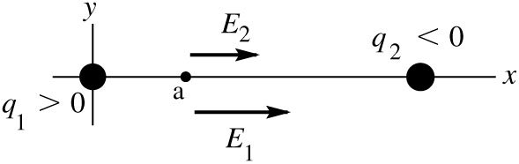
Figure 21.45b

Execute:
The resultant field at point a has magnitude 574 N/C and is in the +x-direction.
(ii) Set Up: At point b the fields are directed as shown in Figure 21.45c.

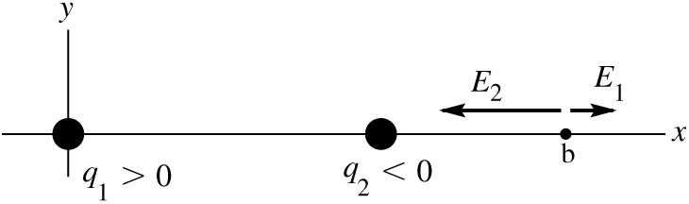
Figure 21.45c

Execute:
The resultant field at point b has magnitude 268 N/C and is in the
(iii) Set Up: At point c the fields are directed as shown in Figure 21.45d.

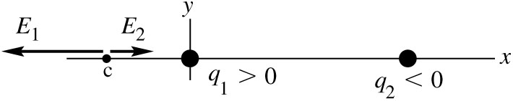
Figure 21.45d
Execute:
The resultant field at point b has magnitude 404 N/C and is in the
(b) Set Up: Since we have calculated at each point the simplest way to get the force is to use
Execute: (i)
(ii)
(iii)
Evaluate: The general rule for electric field direction is away from positive charge and toward negative charge. Whether the field is in the +x- or −x-direction depends on where the field point is relative to the charge that produces the field. In part (a), for (i) the field magnitudes were added because the fields were in the same direction and in (ii) and (iii) the field magnitudes were subtracted because the two fields were in opposite directions. In part (b) we could have used Coulomb’s law to find the forces on the electron due to the two charges and then added these force vectors, but using the resultant electric field is much easier.
21.47. Identify: The net field is the vector sum of the fields due to each charge.
Set Up: The electric field of a negative charge is directed toward the charge. Label the charges and as shown in Figure 21.47a. This figure also shows additional distances and angles. The electric fields at point P are shown in Figure 21.47b. This figure also shows the xy coordinates we will use and the x and y components of the fields , and
Execute:
and
toward the charge.
Evaluate: The x-components of the fields of all three charges are in the same direction.
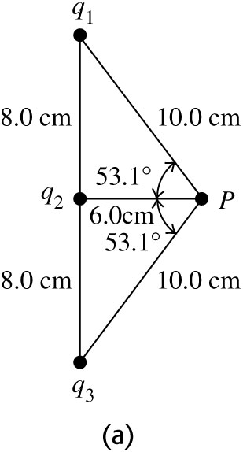 |  | 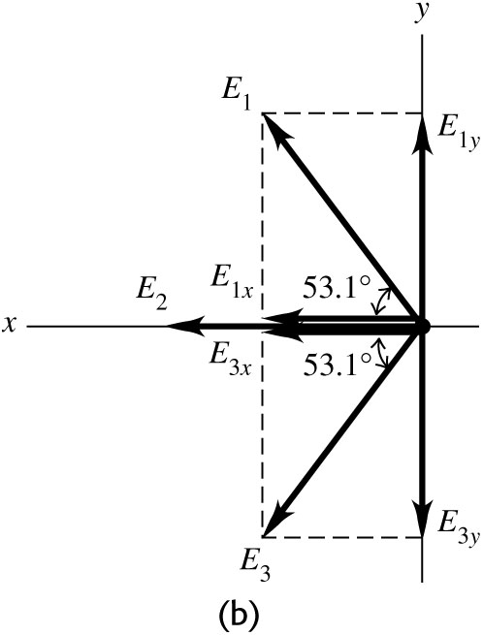
Figure 21.47
21.52. Identify: For a long straight wire, .
Set Up:
Execute:
Evaluate: For a point charge, E is proportional to For a long straight line of charge, E is proportional to
21.54. (a) Identify: The field is caused by a finite uniformly charged wire.
Set Up: The field for such a wire a distance x from its midpoint is
.
Execute: directed upward.
(b) Identify: The field is caused by a uniformly charged circular wire.
Set Up: The field for such a wire a distance x from its midpoint is . We first find the radius of the circle using
Execute: Solving for r gives
The charge on this circle is
The electric field is
upward.
Evaluate: In both cases, the fields are of the same order of magnitude, but the values are different because the charge has been bent into different shapes.

