Physics 104 Assignment 23

23.1. Identify: Apply Eq. (23.2) to calculate the work. The electric potential energy of a pair of point charges is given by Eq. (23.9).
Set Up: Let the initial position of be point a and the final position be point b, as shown in Figure 23.1.

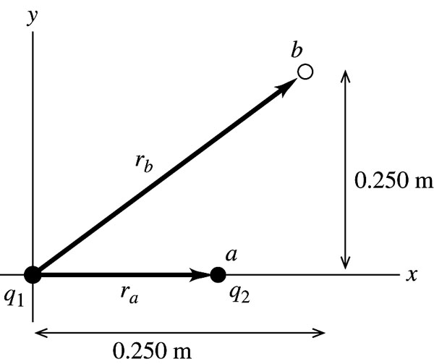
Figure 23.1

Execute:
Evaluate: The attractive force on is toward the origin, so it does negative work on when moves to larger r.
23.3. Identify: The work needed to assemble the nucleus is the sum of the electrical potential energies of the protons in the nucleus, relative to infinity.
set up: The total potential energy is the scalar sum of all the individual potential energies, where each potential energy is Each charge is e and the charges are equidistant from each other, so the total potential energy is
Execute: Adding the potential energies gives
Evaluate: This is a small amount of energy on a macroscopic scale, but on the scale of atoms, 2 MeV is quite a lot of energy.
23.5. (a) Identify: Use conservation of energy:
U for the pair of point charges is given by Eq. (23.9).
Set Up:

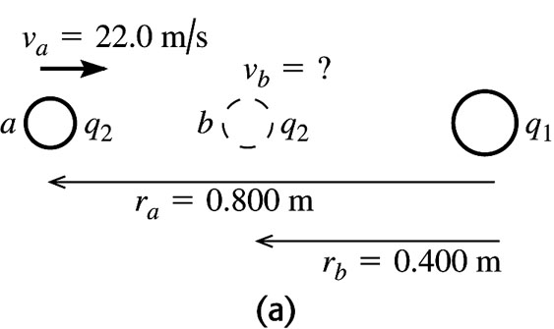 |  | Let point a be where is 0.800 m from  and point b be where is 0.400 m  from as shown in Figure 23.5a.
Figure 23.5a

Execute: Only the electric force does work, so and
The conservation of energy equation then gives
Evaluate: The potential energy increases when the two positively charged spheres get closer together, so the kinetic energy and speed decrease.
(b) Identify: Let point c be where has its speed momentarily reduced to zero. Apply conservation of energy to points a and c:
Set Up: Points a and c are shown in Figure 23.5b.

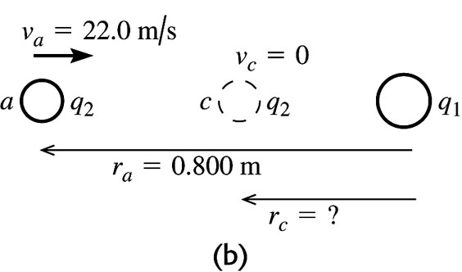 |  | Execute: (from part (a))  (from part (a))
Figure 23.5b

(at distance of closest approach the speed is zero)
Thus conservation of energy gives
Evaluate: as so will stop no matter what its initial speed is.
23.6. Identify: The total potential energy is the scalar sum of the individual potential energies of each pair of charges.
Set Up: For a pair of point charges the electrical potential energy is In the O-H-N combination the is 0.170 nm from the and 0.280 nm from the In the N-H-N combination the is 0.190 nm from the and 0.300 nm from the other U is positive for like charges and negative for unlike charges.
Execute: (a) O-H-N:
N-H-N:
The total potential energy is
(b) In the hydrogen atom the electron is 0.0529 nm from the proton.
Evaluate: The magnitude of the potential energy in the hydrogen atom is about a factor of 4 larger than what it is for the adenine-thymine bond.
23.10. Identify: The work done on the alpha particle is equal to the difference in its potential energy when it is moved from the midpoint of the square to the midpoint of one of the sides.
Set Up: We apply the formula In this case, a is the center of the square and b is the midpoint of one of the sides. Therefore is the work done by the Coulomb force.
There are 4 electrons, so the potential energy at the center of the square is 4 times the potential energy of a single alpha-electron pair. At the center of the square, the alpha particle is a distance from each electron. At the midpoint of the side, the alpha is a distance from the two nearest electrons and a distance from the two most distant electrons. Using the formula for the potential energy (relative to infinity) of two point charges, the total work done by the Coulomb force is
Substituting and and simplifying gives
Execute: Substituting the numerical values into the equation for the work gives
Evaluate: Since the work done by the Coulomb force is positive, the system has more potential energy with the alpha particle at the center of the square than it does with it at the midpoint of a side. To move the alpha particle to the midpoint of a side and leave it there at rest an external force must do of work.
23.14. Identify: The work-energy theorem says
Set Up: Point a is the starting point and point b is the ending point. Since the field is uniform, The field is to the left so the force on the positive charge is to the left. The particle moves to the left so and the work is positive.
Execute: (a)
(b) Point a is at higher potential than point b.
(c) so
Evaluate: A positive charge gains kinetic energy when it moves to lower potential;
23.15. Identify: Apply the equation that precedes Eq. (23.17):
Set Up: Use coordinates where is upward and is to the right. Then with
(a) The path is sketched in Figure 23.15a.

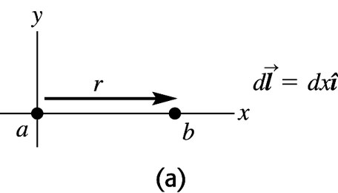
Figure 23.15a

Execute: so
Evaluate: The electric force on the positive charge is upward (in the direction of the electric field) and does no work for a horizontal displacement of the charge.
(b) Set Up: The path is sketched in Figure 23.15b.

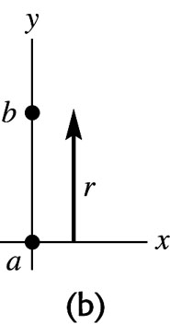
Figure 23.15b

Execute:
positive since the displacement is upward and we have taken to be upward.
Evaluate: The electric force on the positive charge is upward so it does positive work for an upward displacement of the charge.
(c) Set Up: The path is sketched in Figure 23.15c.

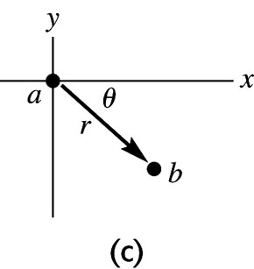 |  | The vertical component of the 2.60 m  displacement is 1.838 m downward.
Figure 23.15c

Execute: (The displacement has both horizontal and vertical components.)
(Only the vertical component of the displacement contributes to the work.)
Evaluate: The electric force on the positive charge is upward so it does negative work for a displacement of the charge that has a downward component.
23.24. Identify: For a point charge, and
Set Up: The electric field is directed toward a negative charge and away from a positive charge.
Execute: (a) so
(b)
(c) so the electric field is directed away from the charge.
Evaluate: The ratio of V to E due to a point charge increases as the distance r from the charge increases, because E falls off as and V falls off as
23.28. Identify and Set Up: Expressions for the electric potential inside and outside a solid conducting sphere are derived in Example 23.8.
Execute: (a) This is outside the sphere, so
(b) This is at the surface of the sphere, so
(c) This is inside the sphere. The potential has the same value as at the surface, 131 V.
Evaluate: All points of a conductor are at the same potential.
23.29. (a) Identify and Set Up: The electric field on the ring’s axis is calculated in Example 21.9. The force on the electron exerted by this field is given by Eq. (21.3).
Execute: When the electron is on either side of the center of the ring, the ring exerts an attractive force directed toward the center of the ring. This restoring force produces oscillatory motion of the electron along the axis of the ring, with amplitude 30.0 cm. The force on the electron is not of the form F = –kx so the oscillatory motion is not simple harmonic motion.
(b) Identify: Apply conservation of energy to the motion of the electron.
Set Up: with a at the initial position of the electron and b at the center of the ring. From Example 23.11, where R is the radius of the ring.
Execute:
(released from rest),
Thus
And so
Evaluate: The positively charged ring attracts the negatively charged electron and accelerates it. The electron has its maximum speed at this point. When the electron moves past the center of the ring the force on it is opposite to its motion and it slows down.
23.31. Identify: The voltmeter measures the potential difference between the two points. We must relate this quantity to the linear charge density on the wire.
Set Up: For a very long (infinite) wire, the potential difference between two points is
Execute: (a) Solving for gives
(b) The meter will read less than 575 V because the electric field is weaker over this 1.00-cm distance than it was over the 1.00-cm distance in part (a).
(c) The potential difference is zero because both probes are at the same distance from the wire, and hence at the same potential.
Evaluate: Since a voltmeter measures potential difference, we are actually given even though that is not stated explicitly in the problem.
23.38. Identify and Set Up: For oppositely charged parallel plates, between the plates and the potential difference between the plates is
Execute: (a)
(b)
(c) The electric field stays the same if the separation of the plates doubles. The potential difference between the plates doubles.
Evaluate: The electric field of an infinite sheet of charge is uniform, independent of distance from the sheet. The force on a test charge between the two plates is constant because the electric field is constant. The potential difference is the work per unit charge on a test charge when it moves from one plate to the other. When the distance doubles, the work, which is force times distance, doubles and the potential difference doubles.
23.39. Identify and Set Up: Use the result of Example 23.9 to relate the electric field between the plates to the potential difference between them and their separation. The force this field exerts on the particle is given by Eq. (21.3). Use the equation that precedes Eq. (23.17) to calculate the work.
Execute: (a) From Example 23.9,
(b)
(c) The electric field between the plates is shown in Figure 23.39.

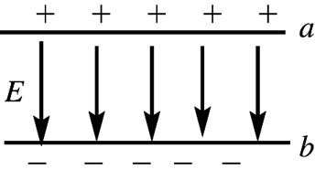
Figure 22.39

The plate with positive charge (plate a) is at higher potential. The electric field is directed from high potential toward low potential (or, is from + charge toward charge), so points from a to b. Hence the force that exerts on the positive charge is from a to b, so it does positive work.
where d is the separation between the plates.
(d) (plate a is at higher potential)
Evaluate: We see that

