Physics 104 Assignment 24

24.1. Identify: The capacitance depends on the geometry (area and plate separation) of the plates.
Set Up: For a parallel-plate capacitor, and
Execute: (a)
(b) Solving for the area gives
(c)
Evaluate: The capacitance is reasonable for laboratory capacitors, but the area is rather large.
24.3. Identify and Set Up: It is a parallel-plate air capacitor, so we can apply the equations of Section 24.1.
Execute: (a) so
(b) so
(c) so
(d) so
Evaluate: We could also calculate directly as Q/A. which checks.
24.5. Identify:
Set Up: When the capacitor is connected to the battery,
Execute: (a)
(b) When d is doubled C is halved, so Q is halved.
(c) If r is doubled, A increases by a factor of 4. C increases by a factor of 4 and Q increases by a factor
of 4.
Evaluate: When the plates are moved apart, less charge on the plates is required to produce the same potential difference. With the separation of the plates constant, the electric field must remain constant to produce the same potential difference. The electric field depends on the surface charge density, To produce the same more charge is required when the area increases.
24.11. Identify: Apply the results of Example 24.4.
Set Up:
Execute: (a)
(b)
Evaluate: This value is similar to those in Example 24.4. The capacitance is determined entirely by the dimensions of the cylinders.
24.12. Identify and Set Up: Use the expression for derived in Example 24.4. Then use Eq. (24.1) to calculate Q.
Execute: (a) From Example 24.4,
(b)
The conductor at higher potential has the positive charge, so there is +64 pC on the inner conductor
and −64 pC on the outer conductor.
Evaluate: C depends only on the dimensions of the capacitor. Q and V are proportional.
24.13. Identify: We can use the definition of capacitance to find the capacitance of the capacitor, and then relate the capacitance to geometry to find the inner radius.
(a) Set Up: By the definition of capacitance,
Execute:
(b) Set Up: The capacitance of a spherical capacitor is
Execute: Solve for and evaluate using and giving
(c) Set Up: We can treat the inner sphere as a point charge located at its center and use Coulomb’s law,
Execute:
Evaluate: Outside the capacitor, the electric field is zero because the charges on the spheres are equal in magnitude but opposite in sign.
24.17. Identify: Replace series and parallel combinations of capacitors by their equivalents. In each equivalent network apply the rules for Q and V for capacitors in series and parallel; start with the simplest network and work back to the original circuit.
Set Up: Do parts (a) and (b) together. The capacitor network is drawn in Figure 24.17a.

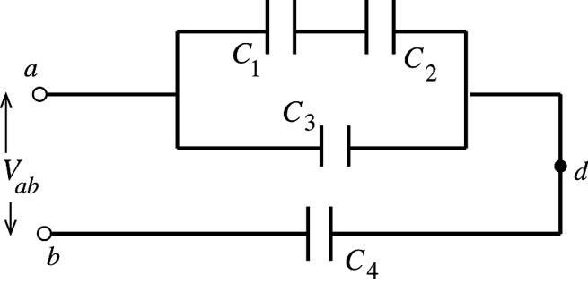
Figure 24.17a

Execute: Simplify the circuit by replacing the capacitor combinations by their equivalents: are in series and are equivalent to (Figure 24.17b).

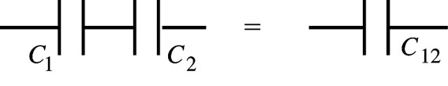
Figure 24.17b

are in parallel and are equivalent to (Figure 24.17c).

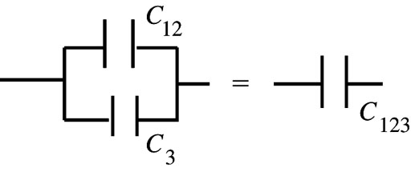
Figure 24.17c

are in series and are equivalent to (Figure 24.17d).

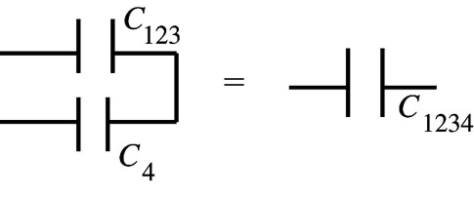
Figure 24.17d

The circuit is equivalent to the circuit shown in Figure 24.17e.

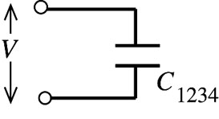
Figure 24.17e
Now build back up the original circuit, step by step. represents in series
(Figure 24.17f).

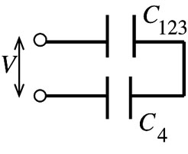 |  | (charge same for capacitors in series)
Figure 24.17f

Then
Note that
Next consider the circuit as written in Figure 24.17g.

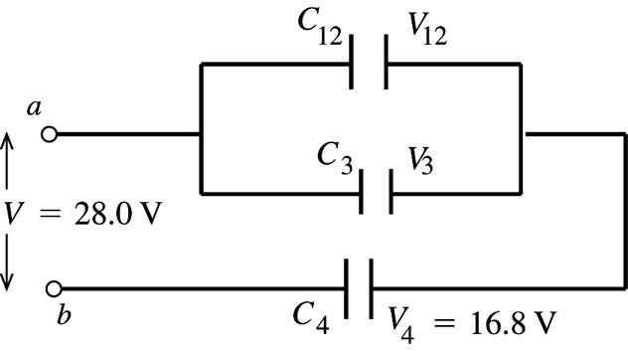
Figure 24.17g

Finally, consider the original circuit, as shown in Figure 24.17h.

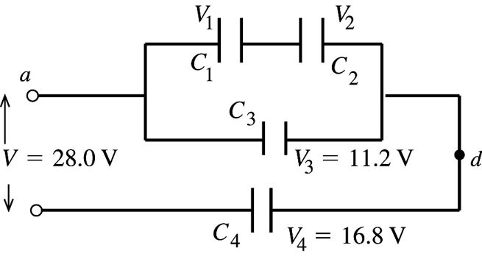 |  | (charge same for capacitors in series)
Figure 24.17h

Note that which equals as it should.
Summary:
(c)
Evaluate:
24.20. Identify: For capacitors in parallel the voltages are the same and the charges add. For capacitors in series, the charges are the same and the voltages add.
Set Up: and are in parallel and is in series with the parallel combination of and
Execute: (a) are in parallel and so have the same potential across them: Therefore, Since is in series with the parallel combination of its charge must be equal to their combined charge:
(b) The total capacitance is found from and
Evaluate:
24.25. Identify and Set Up: The energy density is given by Eq. (24.11): to solve
for E.
Execute: Calculate
Then
Evaluate: E is smaller than the value in Example 24.8 by about a factor of 6 so u is smaller by about a factor of
24.36. Identify: and With the dielectric present,
Set Up: holds both with and without the dielectric.
Execute: (a)
(b) With the dielectric, V is still 45.0 V, so
Evaluate: The presence of the dielectric increases the amount of charge that can be stored for a given potential difference and electric field between the plates. Q increases by a factor of K.
24.43. (a) Identify and Set Up: Since the capacitor remains connected to the power supply the potential difference doesn’t change when the dielectric is inserted. Use Eq. (24.9) to calculate V and combine it with Eq. (24.12) to obtain a relation between the stored energies and the dielectric constant and use this to calculate K.
Execute: Before the dielectric is inserted so
(b)
Evaluate: K increases the capacitance and then from with V constant an increase in C gives an increase in U.

