Physics 104 Assignment 25

25.1. Identify and Set Up: The lightning is a current that lasts for a brief time.
Execute:
Evaluate: Even though it lasts for only 40 µs, the lightning carries a huge amount of charge since it is an enormous current.
25.3. Identify:
Set Up: with The charge of an electron has magnitude
Execute: (a) The number of electrons is
(b)
(c)
Evaluate: (d) If I is the same, would decrease and would decrease. The number of electrons passing through the light bulb in 1.00 s would not change.
25.8. Identify: Positive charge flowing in one direction is equivalent to negative charge flowing in the opposite direction, so the two currents due to and are in the same direction and add.
Set Up: and each have magnitude of charge
Execute: (a) Then
(b) Current flows, by convention, in the direction of positive charge. Thus, current flows with toward the negative electrode.
Evaluate: The ions have negative charge and move in the direction opposite to the conventional current direction.
25.10. (a) Identify: Start with the definition of resistivity and solve for E.
Set Up:
Execute:
Evaluate: The field is quite weak, since the potential would drop only a volt in 70 m of wire.
(b) Identify: Take the ratio of the field in silver to the field in copper.
Set Up: Take the ratio and solve for the field in silver:
Execute:
Evaluate: Since silver is a better conductor than copper, the field in silver is smaller than the field in copper.
25.17. Identify:
Set Up: For copper,
Execute:
Evaluate: The resistance is proportional to the length of the piece of wire.
25.21. Identify:
Set Up: the length of one side of the cube.
Execute:
Evaluate: The resistance is very small because A is very much larger than the typical value for a wire.
25.23. Identify and Set Up: Eq. (25.5) relates the electric field that is given to the current density. gives the potential difference across a length L of wire and Eq. (25.11) allows us to calculate R.
Execute: (a) Eq. (25.5):
From Table 25.1 the resistivity for gold is
(b)
(c) We can use Ohm’s law (Eq. (25.11)):
Evaluate: We can also calculate R from the resistivity and the dimensions of the wire (Eq. 25.10):
which checks.
25.29. Identify: Use to calculate R and then apply and
Set Up: For copper, where
Execute: (a)
(b) and
Evaluate: The rate of electrical energy loss in the cable is large, over 3 kW.
25.38. Identify and Set Up: There is a single current path so the current is the same at all points in the circuit. Assume the current is counterclockwise and apply Kirchhoff’s loop rule.
Execute: (a) Apply the loop rule, traveling around the circuit in the direction of the current. Our calculated
I is positive so I is counterclockwise, as we assumed.
(b)
Evaluate: If we traveled around the circuit in the direction opposite to the current, the final answers would be the same.
25.39. Identify: The bulbs are each connected across a 120-V potential difference.
Set Up: Use to solve for R and Ohm’s law to find the current.
Execute: (a)
(b)
(c) For the 100-W bulb:
For the 60-W bulb:
Evaluate: The 60-W bulb has more resistance than the 100-W bulb, so it draws less current.
25.42. Identify:
Set Up:
Execute:
Evaluate: The energy consumed is proportional to the voltage, to the current and to the time.
25.49. Identify: Some of the power generated by the internal emf of the battery is dissipated across the battery’s internal resistance, so it is not available to the bulb.
Set Up: Use and take the ratio of the power dissipated in the internal resistance r to the total power.
Execute:
Evaluate: About 88% of the power of the battery goes to the bulb. The rest appears as heat in the internal resistance.
25.51. Identify: Solve for the current I in the circuit. Apply Eq. (25.17) to the specified circuit elements to find the rates of energy conversion.
Set Up: The circuit is sketched in Figure 25.51

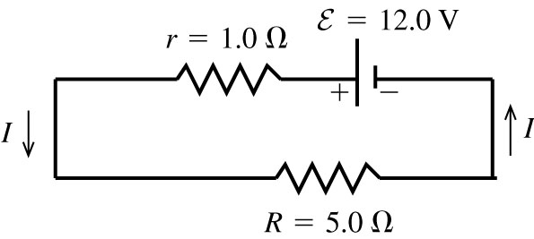 |  | Execute: Compute I:
Figure 25.51
(a) The rate of conversion of chemical energy to electrical energy in the emf of the battery is
(b) The rate of dissipation of electrical energy in the internal resistance of the battery is
(c) The rate of dissipation of electrical energy in the external resistor
Evaluate: The rate of production of electrical energy in the circuit is 24.0 W. The total rate of consumption of electrical energy in the circuit is Equal rate of production and consumption of electrical energy are required by energy conservation.
25.53. Identify:
Set Up: The heater consumes 540 W when
Execute: (a) so
(b) so
(c) Assuming that R remains P is smaller by a factor of
Evaluate: (d) With the lower line voltage the current will decrease and the operating temperature will decrease. R will be less than and the power consumed will be greater than the value calculated in part (c).

