Physics 104 Assignment 26

26.3. Identify: The emf of the battery remains constant, but changing the resistance across it changes its power output.
Set Up: The power output across a resistor is
Execute: With just and is the battery voltage. With added,
Evaluate: The two resistors in series dissipate electrical energy at a smaller rate than alone.
26.4. Identify: For resistors in parallel the voltages are the same and equal to the voltage across the
equivalent resistance.
Set Up:
Execute: (a)
(b)
(c)
Evaluate: More current flows through the resistor that has the smaller R.
26.7. Identify: First do as much series-parallel reduction as possible.
Set Up: The 45.0-Ω and 15.0-Ω resistors are in parallel, so first reduce them to a single equivalent resistance. Then find the equivalent series resistance of the circuit.
Execute: The total equivalent resistance is Ohm’s law gives
Evaluate: The circuit appears complicated until we realize that the 45.0-Ω and 15.0-Ω resistors are in parallel.
26.8. Identify: Eq. (26.2) gives the equivalent resistance of the three resistors in parallel. For resistors in parallel, the voltages are the same and the currents add.
(a) Set Up: The circuit is sketched in Figure 26.8a.

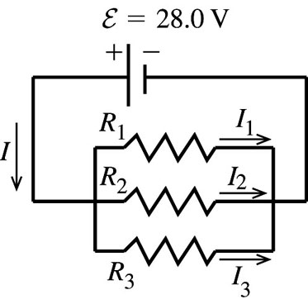 |  | Execute: parallel
Figure 26.8a

(b) For resistors in parallel the voltage is the same across each and equal to the applied voltage;
(c) The currents through the resistors add to give the current through the battery:
Evaluate: Alternatively, we can use the equivalent resistance as shown in Figure 26.8b.

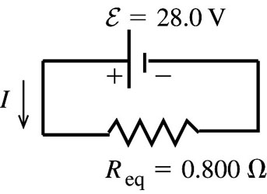 |  | which checks
Figure 26.8b

(d) As shown in part (b), the voltage across each resistor is 28.0 V.
(e) Identify and Set Up: We can use any of the three expressions for They will all give the same results, if we keep enough significant figures in intermediate calculations.
Execute: Using
Evaluate: The total power dissipated is This is the same as the power delivered by the battery.
(f) The resistors in parallel each have the same voltage, so the power P is largest for the one with the least resistance.
26.10. (a) Identify: The current, and hence the power, depends on the potential difference across the resistor.
Set Up:
Execute: (a)
(b)
Set Up: (c) If the larger resistor generates 2.00 W, the smaller one will generate less and hence will be safe. Therefore the maximum power in the larger resistor must be 2.00 W. Use to find the maximum current through the series combination and use Ohm’s law to find the potential difference across the combination.
Execute: gives The same current flows through both resistors, and their equivalent resistance is Ohm’s law gives Therefore and
Evaluate: If the resistors in a series combination all have the same power rating, it is the largest resistance that limits the amount of current.
26.13. Identify: For resistors in parallel, the voltages are the same and the currents add. so For resistors in series, the currents are the same and the voltages add.
Set Up: The rules for combining resistors in series and parallel lead to the sequences of equivalent circuits shown in Figure 26.13.
Execute: In Figure 26.13c, This is the current through each of the resistors in Figure 26.13b. Note that is the voltage across and across so and is the voltage across and across so and
Evaluate: Note that

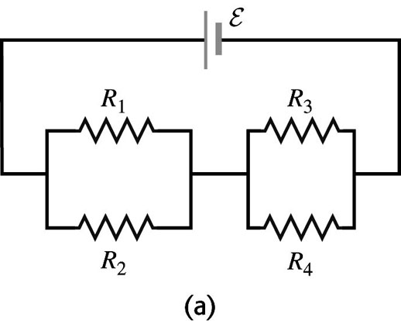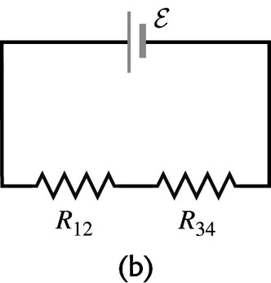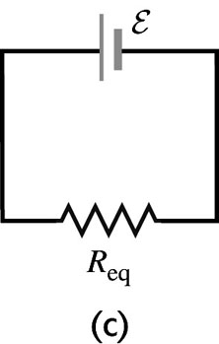
Figure 26.13
26.17. Identify: Apply Ohm’s law to each resistor.
Set Up: For resistors in parallel the voltages are the same and the currents add. For resistors in series the currents are the same and the voltages add.
Execute: The current through the resistor is 6.00 A. Current through the resistor also is 6.00 A and the voltage is 6.00 V. Voltage across the resistor is Current through the resistor is The battery emf is 18.0 V.
Evaluate: The current through the battery is The equivalent resistor of the resistor network is and this equals
26.25. Identify: Apply Kirchhoff’s point rule at point a to find the current through R. Apply Kirchhoff’s loop rule to loops (1) and (2) shown in Figure 26.25a to calculate R and Travel around each loop in the direction shown.
(a) Set Up:

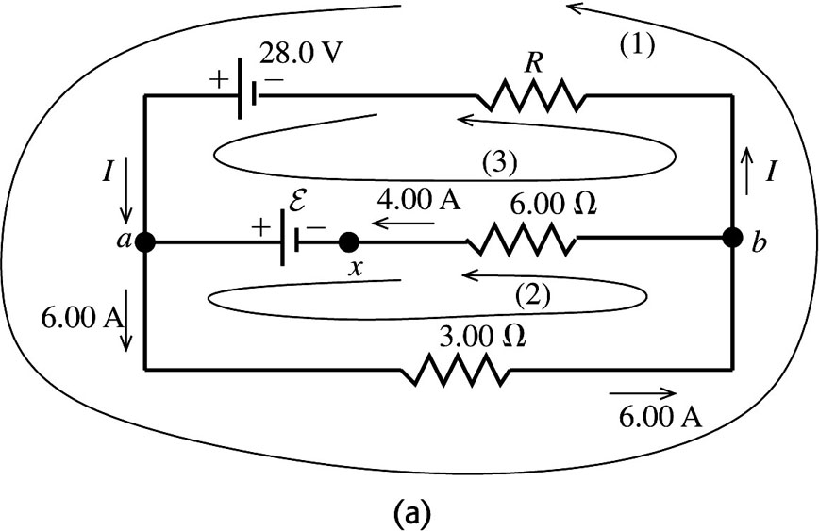
Figure 26.25a

Execute: Apply Kirchhoff’s point rule to point a:
(in the direction shown in the diagram).
(b) Apply Kirchhoff’s loop rule to loop (1):
(c) Apply Kirchhoff’s loop rule to loop (2):
Evaluate: Can check that the loop rule is satisfied for loop (3), as a check of our work:
so the loop rule is satisfied for this loop.
(d) Identify: If the circuit is broken at point x there can be no current in the resistor. There is now only a single current path and we can apply the loop rule to this path.
Set Up: The circuit is sketched in Figure 26.25b.

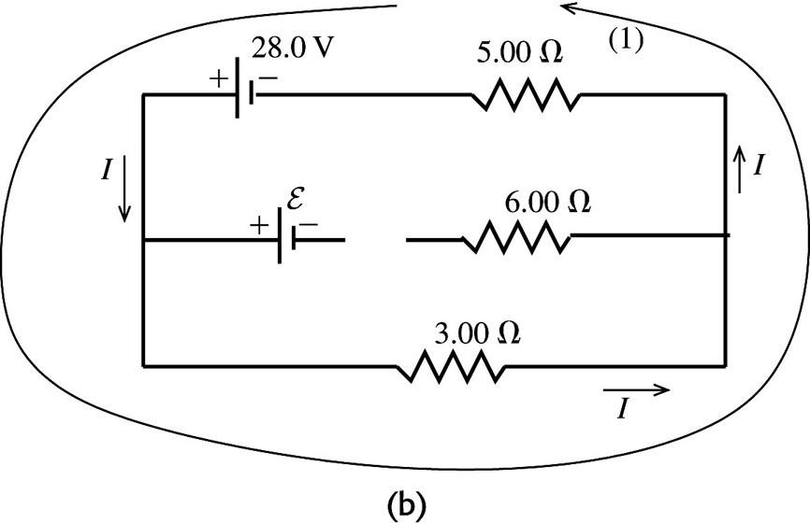
Figure 26.25b
Execute:
Evaluate: Breaking the circuit at x removes the 42.0-V emf from the circuit and the current through the resistor is reduced.
26.27. Identify: Apply the junction rule at points a, b, c and d to calculate the unknown currents. Then apply the loop rule to three loops to calculate
(a) Set Up: The circuit is sketched in Figure 26.27.
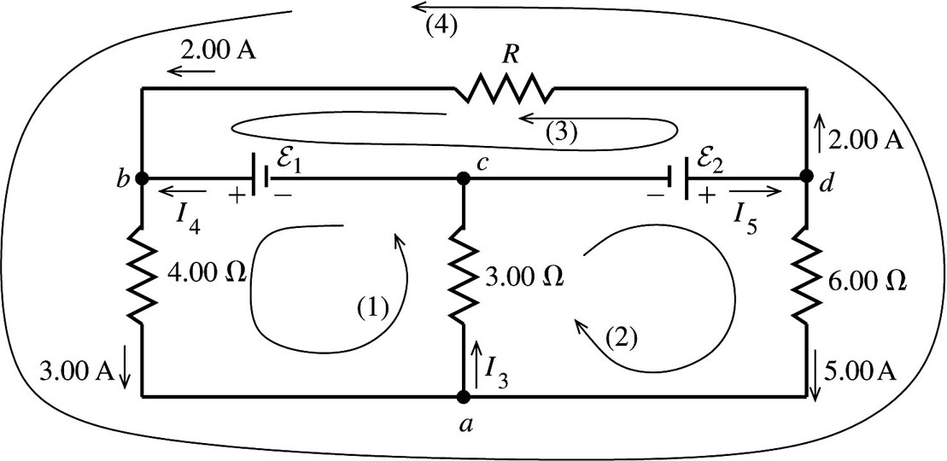
Figure 26.27

Execute: Apply the junction rule to point a:
Apply the junction rule to point b:
Apply the junction rule to point c:
Evaluate: As a check, apply the junction rule to point d:
(b) Execute: Apply the loop rule to loop (1):
Apply the loop rule to loop (2):
(c) Apply the loop rule to loop (3):
Evaluate: Apply the loop rule to loop (4) as a check of our calculations:
26.28. Identify: Use Kirchhoff’s rules to find the currents.
Set Up: Since the 10.0-V battery has the larger voltage, assume is to the left through the 10-V battery, is to the right through the 5 V battery, and is to the right through the resistor. Go around each loop in the counterclockwise direction.
Execute: Upper loop: This gives and
Lower loop: This gives and
Along with we can solve for the three currents and find:
(b)
Evaluate: Traveling from b to a through the and resistors you pass through the resistors in the direction of the current and the potential decreases; point b is at higher potential than point a.
26.40. Identify: An uncharged capacitor is placed into a circuit. Apply the loop rule at each time.
Set Up: The voltage across a capacitor is
Execute: (a) At the instant the circuit is completed, there is no voltage across the capacitor, since it has no charge stored.
(b) Since the full battery voltage appears across the resistor
(c) There is no charge on the capacitor.
(d) The current through the resistor is
(e) After a long time has passed the full battery voltage is across the capacitor and The voltage across the capacitor balances the emf: The voltage across the resistor is zero. The capacitor’s charge is The current in the circuit is zero.
Evaluate: The current in the circuit starts at 0.0327 A and decays to zero. The charge on the capacitor starts at zero and rises to
26.41. Identify: The capacitor discharges exponentially through the voltmeter. Since the potential difference across the capacitor is directly proportional to the charge on the plates, the voltage across the plates decreases exponentially with the same time constant as the charge.
Set Up: The reading of the voltmeter obeys the equation where RC is the time constant.
Execute: (a) Solving for C and evaluating the result when gives
(b)
Evaluate: In most laboratory circuits, time constants are much shorter than this one.
26.46. Identify: The charge is increasing while the current is decreasing. Both obey exponential equations, but they are not the same equation.
Set Up: The charge obeys the equation but the equation for the current is
Execute: When the charge has reached of its maximum value, we have which says that the exponential term has the value The current at this time is
Evaluate: Notice that the current will be not of its maximum value when the charge is of its maximum. Although current and charge both obey exponential equations, the equations have different forms for a charging capacitor.

