Physics 104 Assignment 27

27.1. Identify and Set Up: Apply Eq. (27.2) to calculate Use the cross products of unit vectors from Section 1.10.
Execute:
(a)
Evaluate: The directions of are shown in Figure 27.1a.

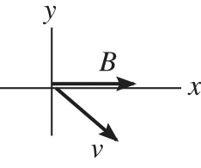 |  | The right-hand rule gives that is  directed out of the paper  The charge is negative so is opposite  to
Figure 27.1a

is in the This agrees with the direction calculated with unit vectors.
(b) Execute:
Evaluate: The directions of are shown in Figure 27.1b.

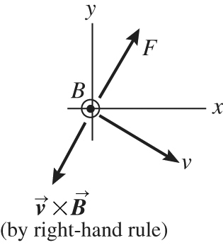 |  | The direction of is opposite to since  q is negative. The direction of computed  from the right-hand rule agrees qualitatively  with the direction calculated with unit vectors.
Figure 27.1b
27.3. Identify: The force on the particle is in the direction of the deflection of the particle. Apply the right-hand rule to the directions of and See if your thumb is in the direction of or opposite to that direction. Use with to calculate F.
Set Up: The directions of and are shown in Figure 27.3.
Execute: (a) When you apply the right-hand rule to and your thumb points east. is in this direction, so the charge is positive.
(b)
Evaluate: If the particle had negative charge and and are unchanged, the particle would be deflected toward the west.

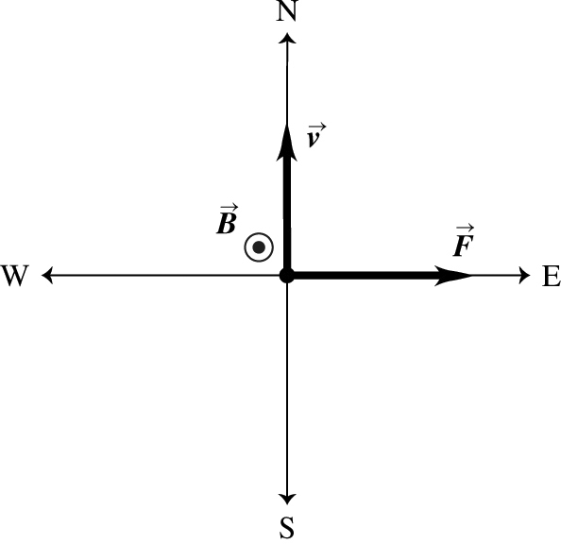
Figure 27.3
27.5. Identify: Apply and solve for v.
Set Up: An electron has
Execute:
Evaluate: Only the component of the magnetic field perpendicular to the velocity contributes to the force.
27.10. Identify: Knowing the area of a surface and the magnetic field it is in, we want to calculate the flux through it.
Set Up: so
Execute:
Evaluate: Since the field is uniform over the surface, it is not necessary to integrate to find the flux.
27.11. Identify and Set Up:
Circular area in the xy-plane, so and is in the Use Eq. (1.18) to calculate the scalar product.
Execute: (a) are parallel so
B is constant over the circular area so
(b) The directions of are shown in Figure 27.11a.

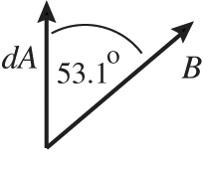
Figure 27.11a

B and are constant over the circular area so
(c) The directions of are shown in Figure 27.11b.

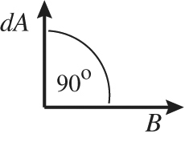
Figure 27.11b

Evaluate: Magnetic flux is a measure of how many magnetic field lines pass through the surface. It is maximum when is perpendicular to the plane of the loop (part a) and is zero when is parallel to the plane of the loop (part c).
27.15. (a) Identify: Apply Eq. (27.2) to relate the magnetic force to the directions of The electron has negative charge so is opposite to the direction of For motion in an arc of a circle the acceleration is toward the center of the arc so must be in this direction.
Set Up:

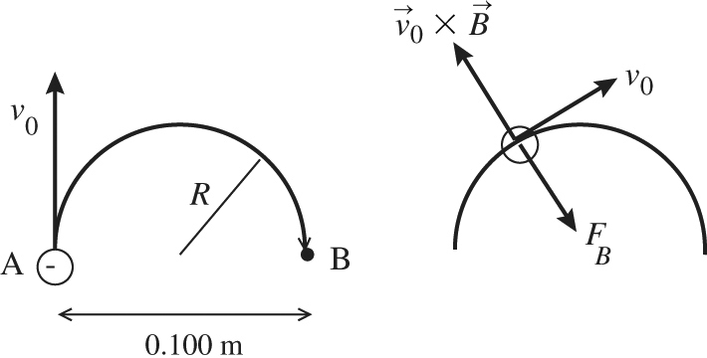 |  | As the electron moves in the semicircle,  its velocity is tangent to the circular path.  The direction of at a point along  the path is shown in Figure 27.15.
Figure 27.15

Execute: For circular motion the acceleration of the electron is directed in toward the center of the circle. Thus the force exerted by the magnetic field, since it is the only force on the electron, must be radially inward. Since q is negative, is opposite to the direction given by the right-hand rule for Thus is directed into the page. Apply Newton’s second law to calculate the magnitude of
(b) Identify and Set Up: The speed of the electron as it moves along the path is constant. changes the direction of but not its magnitude.) The time is given by the distance divided by
Execute: The distance along the semicircular path is so
Evaluate: The magnetic field required increases when v increases or R decreases and also depends on the mass to charge ratio of the particle.
27.18. Identify: Since the particle moves perpendicular to the uniform magnetic field, the radius of its path is The magnetic force is perpendicular to both and
Set Up: The alpha particle has charge
Execute: (a) The alpha particle moves in a circular arc of diameter
(b) For a very short time interval the displacement of the particle is in the direction of the velocity.
The magnetic force is always perpendicular to this direction so it does no work. The work-energy theorem therefore says that the kinetic energy of the particle, and hence its speed, is constant.
(c) The acceleration is We can also use and the result of part (a) to calculate the same result.
The acceleration is perpendicular to and and so is horizontal, toward the center of curvature of the particle’s path.
Evaluate: (d) The unbalanced force is perpendicular to so it changes the direction of but not its magnitude, which is the speed.
27.21. (a) Identify and Set Up: Apply Newton’s second law, with since the path of the particle is circular.
Execute: says
(b) Identify and Set Up: The speed is constant so
Execute:
(c) Identify and Set Up: kinetic energy potential energy lost
Execute:
Evaluate: The deutron has a much larger mass to charge ratio than an electron so a much larger B is required for the same v and R. The deutron has positive charge so gains kinetic energy when it goes from high potential to low potential.
27.30. Identify: For no deflection the magnetic and electric forces must be equal in magnitude and opposite in direction.
Set Up: for no deflection.
Execute: To pass undeflected in both cases,
(a) If the electric field direction is given by since it must point in the opposite direction to the magnetic force.
(b) If the electric field direction is given by since the electric force must point in the opposite direction as the magnetic force. Since the particle has negative charge, the electric force is opposite to the direction of the electric field and the magnetic force is opposite to the direction it has in part (a).
Evaluate: The same configuration of electric and magnetic fields works as a velocity selector for both positively and negatively charged particles.
27.31. Identify: For the alpha particles to emerge from the plates undeflected, the magnetic force on them must exactly cancel the electric force. The battery produces an electric field between the plates, which acts on the alpha particles.
Set Up: First use energy conservation to find the speed of the alpha particles as they enter the region between the plates: The electric field between the plates due to the battery is For the alpha particles not to be deflected, the magnetic force must cancel the electric force, so giving
Execute: Solve for the speed of the alpha particles just as they enter the region between the plates. Their charge is 2e.
The electric field between the plates, produced by the battery, is
The magnetic force must cancel the electric force:
The magnetic field is perpendicular to the electric field. If the charges are moving to the right and the electric field points upward, the magnetic field is out of the page.
Evaluate: The sign of the charge of the alpha particle does not enter the problem, so negative charges of the same magnitude would also not be deflected.
27.38. Identify: Apply
Set Up: is the length of wire in the magnetic field. Since the wire is perpendicular to
Execute:
Evaluate: The force per unit length of wire is proportional to both B and I.
27.42. Identify: The magnetic force must be upward and equal to mg. The direction of is determined by the direction of I in the circuit.
Set Up: with where V is the battery voltage.
Execute: (a) The forces are shown in Figure 27.42. The current I in the bar must be to the right to produce upward. To produce current in this direction, point a must be the positive terminal of the battery.
(b)
Evaluate: If the battery had opposite polarity, with point a as the negative terminal, then the current would be clockwise and the magnetic force would be downward.

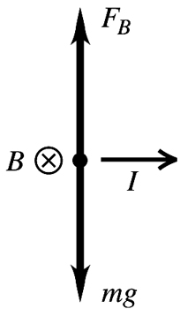
Figure 27.42
27.46. Identify: where is the angle between and the normal to the loop.
Set Up: The coil as viewed along the axis of rotation is shown in Figure 27.46a for its original position and in Figure 27.46b after it has rotated
Execute: (a) The forces on each side of the coil are shown in Figure 27.46a. and The net force on the coil is zero. and so The forces on the coil produce no torque.
(b) The net force is still zero. and the net torque is The net torque is clockwise in
Figure 27.46b and is directed so as to increase the angle
Evaluate: For any current loop in a uniform magnetic field the net force on the loop is zero. The torque on the loop depends on the orientation of the plane of the loop relative to the magnetic field direction.

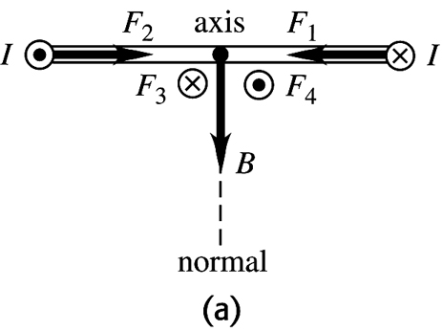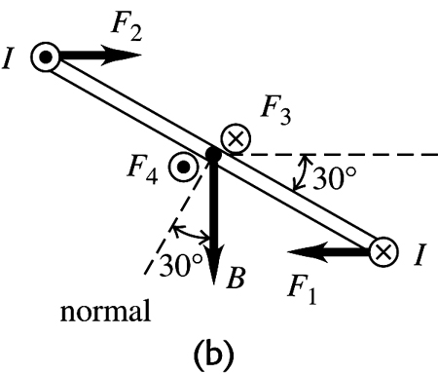
Figure 27.46
27.48. Identify: and where
Set Up: is the angle between and the normal to the plane of the loop.
Execute: (a)
(b)
(c)
(d)
Evaluate: When is maximum, When is maximum,
27.49. Identify and Set Up: The potential energy is given by Eq. (27.27): The scalar product depends on the angle between
Execute: For For
Evaluate: U is maximum when are antiparallel and minimum when they are parallel. When the coil is rotated as specified its magnetic potential energy decreases.

