Physics 104 Assignment 28

28.1. Identify and Set Up: Use Eq. (28.2) to calculate at each point.
and is the vector from the charge to the point where the field is calculated.
Execute: (a)
(b)
(c)
(d)
Evaluate: At each point is perpendicular to both and along the direction of
28.5. Identify: Apply
Set Up: Since the charge is at the origin,
Execute: (a)
(b)
q is negative, so
(c)
(d)
Evaluate: In each case, is perpendicular to both and
28.6. Identify: Apply For the magnetic force, apply the results of Example 28.1, except here the two charges and velocities are different.
Set Up: In part (a), and is perpendicular to in each case, so For calculating the force between the charges,
Execute: (a)
The direction of is into the page.
(b) Following Example 28.1 we can find the magnetic force between the charges:
The force on the upper charge points up and the force on the lower charge points down. The Coulomb force between the charges is The force on the upper charge points up and the force on the lower charge points down. The ratio of the Coulomb force to the magnetic force is the Coulomb force is much larger.
(c) The magnetic forces are reversed in direction when the direction of only one velocity is reversed but the magnitude of the force is unchanged.
Evaluate: When two charges have the same sign and move in opposite directions, the force between them is repulsive. When two charges of the same sign move in the same direction, the force between them is attractive.
28.10. Identify: Apply the Biot-Savart law.
Set Up: Apply
Execute:
Evaluate: The magnetic field lies in the xz-plane.
28.13. Identify and Set Up: The magnetic field produced by an infinitesimal current element is given by Eq. (28.6).
. As in Example 28.2, use this equation for the finite 0.500-mm segment of wire since the length is much smaller than the distances to the field points.
I is in the
Execute: (a) Field point is at so the vector from the source point
(at the origin) to the field point is
(b)
(c)
(d)
Evaluate: At each point is perpendicular to both along the length of the wire.
28.16. Identify: A current segment creates a magnetic field.
Set Up: The law of Biot and Savart gives All four fields are of equal magnitude and into the page, so their magnitudes add.
Execute: into the page.
Evaluate: A small current element causes a small magnetic field.
28.17. Identify: We can model the lightning bolt and the household current as very long current-carrying wires.
Set Up: The magnetic field produced by a long wire is
Execute: Substituting the numerical values gives
(a)
(b)
Evaluate: The field from the lightning bolt is about 20 times as strong as the field from the household current.
28.18. Identify: The long current-carrying wire produces a magnetic field.
Set Up: The magnetic field due to a long wire is
Execute: First find the current:
Now find the magnetic field:
Since electrons are negative, the conventional current runs from east to west, so the magnetic field above the wire points toward the north.
Evaluate: This magnetic field is much less than that of the earth, so any experiments involving such a current would have to be shielded from the earth’s magnetic field, or at least would have to take it into consideration.
28.22. Identify: For each wire (Eq. 28.9), and the direction of is given by the right-hand rule (Figure 28.6 in the textbook). Add the field vectors for each wire to calculate the total field.
(a) Set Up: The two fields at this point have the directions shown in Figure 28.22a.
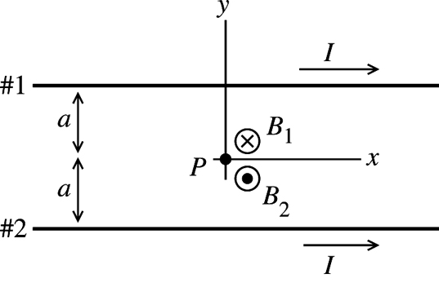 |  | Execute: At point P midway between  the two wires the fields due to  the two currents are in opposite directions,  so
Figure 28.22a

But
(b) Set Up: The two fields at this point have the directions shown in Figure 28.22b.

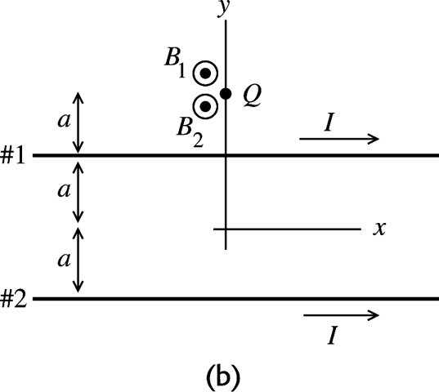 |  | Execute: At point Q above the upper  wire are both directed out of  the page so
Figure 28.22b

(c) Set Up: The two fields at this point have the directions shown in Figure 28.22c.

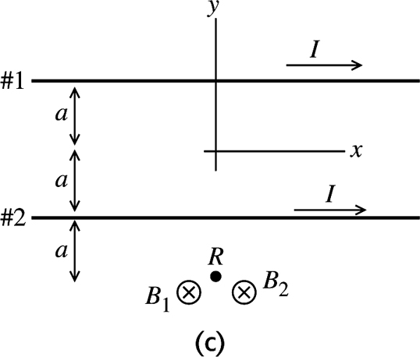 |  | Execute: At point R below the lower  wire are both directed into the  page so
Figure 28.22c

Evaluate: In the figures we have drawn, due to each wire is out of the page at points above the wire and into the page at points below the wire. If the two field vectors are in opposite directions the magnitudes subtract.
28.24. Identify: The magnetic field is that of a long current-carrying wire.
Set Up:
Execute: This is 7.5% of the earth’s field.
Evaluate: Since this field is much smaller than the earth’s magnetic field, it would be expected to have less effect than the earth’s field.
28.25. Identify: The direction of is given by the right-hand rule.
Set Up: Call the wires a and b, as indicated in Figure 28.25. The magnetic fields of each wire at points and are shown in Figure 28.25a. The fields at point 3 are shown in Figure 28.25b.
Execute: (a) At and the two fields are in opposite directions, so the net field is zero.
(b) and are in the same direction so
has magnitude and is directed toward the top of the page.
(c) In Figure 28.25b, is perpendicular to and is perpendicular to and and
B has magnitude and is directed to the left.
Evaluate: At points directly to the left of both wires the net field is directed toward the bottom of the page.
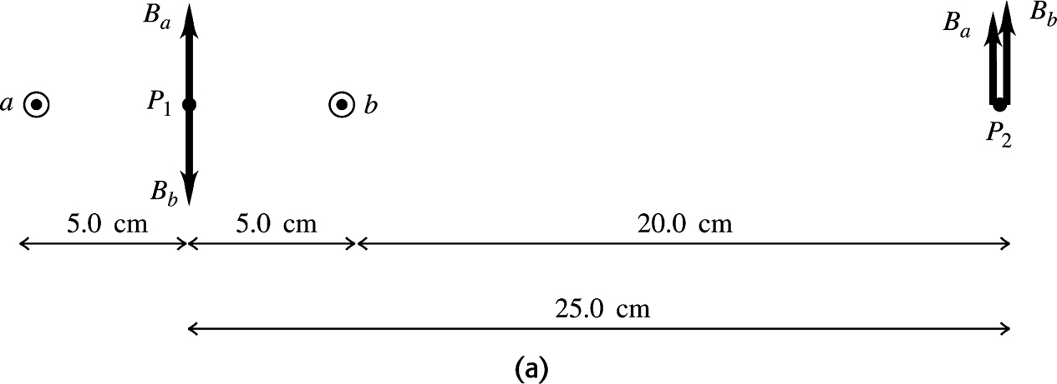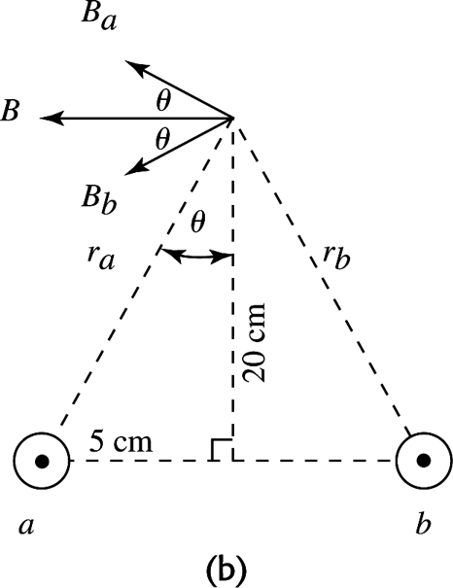
Figure 28.25
28.31. Identify: Apply Eq. (28.11).
Set Up: Two parallel conductors carrying current in the same direction attract each other. Parallel conductors carrying currents in opposite directions repel each other.
Execute: (a) and the force is repulsive since the currents are in opposite directions.
(b) Doubling the currents makes the force increase by a factor of four to
Evaluate: Doubling the current in a wire doubles the magnetic field of that wire. For fixed magnetic field, doubling the current in a wire doubles the force that the magnetic field exerts on the wire.
28.33. Identify: The lamp cord wires are two parallel current-carrying wires, so they must exert a magnetic force on each other.
Set Up: First find the current in the cord. Since it is connected to a light bulb, the power consumed by the bulb is Then find the force per unit length using
Execute: For the light bulb, The force per unit length is
Since the currents are in opposite directions, the force is repulsive.
Evaluate: This force is too small to have an appreciable effect for an ordinary cord.
28.34. Identify: The wire CD rises until the upward force due to the currents balances the downward force of gravity.
Set Up: The forces on wire CD are shown in Figure 28.34.
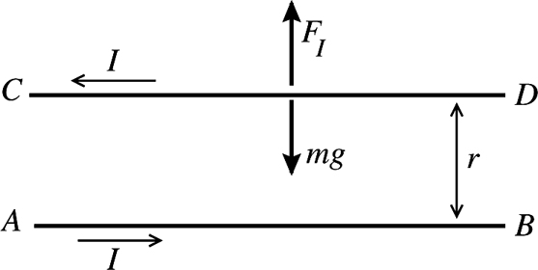 |  | Currents in opposite directions so the force  is repulsive and is upward, as shown.
Figure 28.34

Eq. (28.11) says where L is the length of wire CD and h is the distance between the wires.
Execute:
Thus
Evaluate: The larger I is or the smaller is, the larger h will be.
28.39. Identify: Apply Eq. (28.16).
Set Up: At the center of the coil, a is the radius of the coil, 0.020 m.
Execute: (a)
(b)
Evaluate: As shown in Figure 28.14 in the textbook, the field has its largest magnitude at the center of the coil and decreases with distance along the axis from the center.
28.40. Identify and Set Up: The magnetic field at a point on the axis of N circular loops is given by Solve for N and set
Execute:
Evaluate: At the center of the coil the field is The field 6.00 cm from the center is a factor of times smaller.

