Physics 104 Assignment 33

33.1. Identify: For reflection,
Set Up: The desired path of the ray is sketched in Figure 33.1.
Execute: so and
Evaluate: The angle of incidence is measured from the normal to the surface.

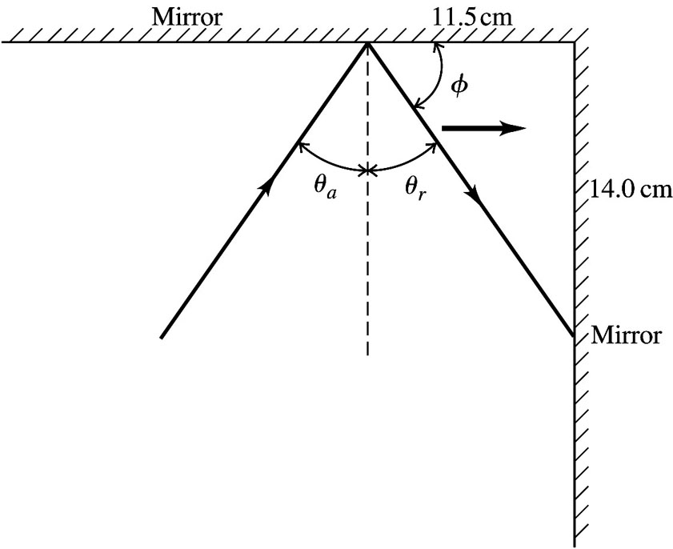
Figure 33.1
33.3. Identify and Set Up: Use Eqs. (33.1) and (33.5) to calculate v and
Execute: (a)
(b)
Evaluate: Light is slower in the liquid than in vacuum. By when v is smaller, is smaller.
33.5. Identify: where is the wavelength in vacuum.
Set Up: n for air is only slightly larger than unity.
Execute: (a)
(b)
Evaluate: In quartz the speed is lower and the wavelength is smaller than in air.
33.7. Identify: Apply Eqs. (33.2) and (33.4) to calculate The angles in these equations are measured with respect to the normal, not the surface.
(a) Set Up: The incident, reflected and refracted rays are shown in Figure 33.7.

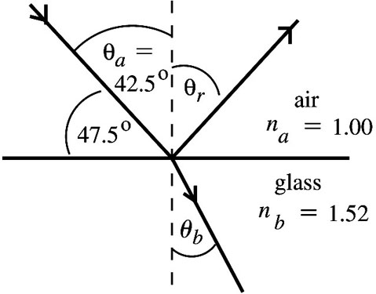 |  | Evaluate: The reflected  ray makes an angle of with  the surface of the glass.
Figure 33.7

(b) where the angles are measured from the normal to the interface.
The refracted ray makes an angle of with the surface of the glass.
Evaluate: The light is bent toward the normal when the light enters the material of larger refractive index.
33.9. Identify and Set Up: Use Snell’s law to find the index of refraction of the plastic and then use
Eq. (33.1) to calculate the speed v of light in the plastic.
Execute:
Evaluate: Light is slower in plastic than in air. When the light goes from air into the plastic it is bent toward the normal.
33.15. Identify: Apply
Set Up:
Execute: and
Evaluate: The ray refracts into a material of smaller n, so it is bent away from the normal.
33.23. Identify: Total internal reflection must be occurring at the glass-water boundary. Snell’s law applies there.
Set Up:
Execute: Apply Snell’s law to find and Then and
Evaluate: The wavelength is greater in the water than it is in the glass, as it must be, since

