Physics 104 Assignment 34

34.1. Identify and Set Up: Plane mirror: (Eq. 34.1) and (Eq. 34.2). We are given s and y and are asked to find
Execute: The object and image are shown in Figure 34.1.

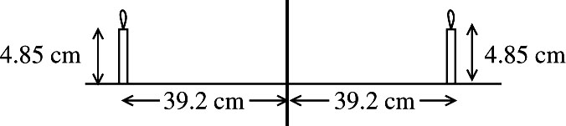
Figure 34.1

The image is 39.2 cm to the right of the mirror and is 4.85 cm tall.
Evaluate: For a plane mirror the image is always the same distance behind the mirror as the object is in front of the mirror. The image always has the same height as the object.
34.5. Identify and Set Up: Use Eq. (34.6) to calculateand use Eq. (34.7) to calculate The image is real if is positive and is erect if Concave means R and f are positive,
Execute: (a)

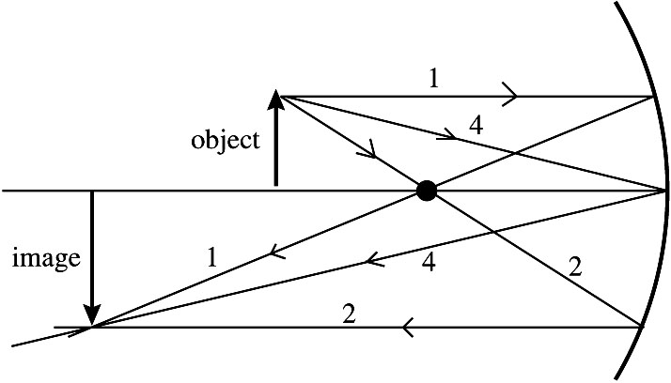 |  | Three principal rays,  numbered as in Section 34.2,  are shown in Figure 34.5.  The principal ray diagram  shows that the image is real,  inverted, and enlarged.
Figure 34.5

(b)
so real image, 33.0 cm to left of mirror vertex
means inverted image)
Evaluate: The image is 33.0 cm to the left of the mirror vertex. It is real, inverted, and is 1.20 cm tall (enlarged). The calculation agrees with the image characterization from the principal ray diagram.
A concave mirror used alone always forms a real, inverted image if and the image is enlarged
if
34.7. Identify: Find m and calculate
Set Up:
Execute: so
Evaluate: The image is real and is 1.75 m in front of the mirror.
34.9. Identify: The shell behaves as a spherical mirror.
Set Up: The equation relating the object and image distances to the focal length of a spherical mirror is and its magnification is given by
Execute: from the vertex. The image is 0.50 cm tall, erect and virtual.
Evaluate: Since the magnification is less than one, the image is smaller than the object.
34.15. Identify: Apply Eq. (34.11), with is the apparent depth.
Set Up: The image and object are shown in Figure 34.15.

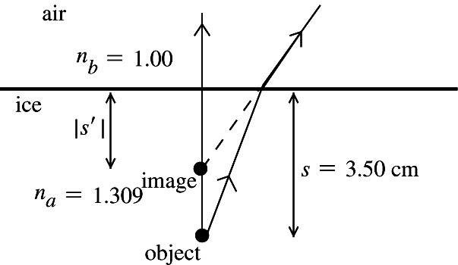 |  | (flat surface), so
Figure 34.15

Execute:
The apparent depth is 2.67 cm.
Evaluate: When the light goes from ice to air (larger to smaller n), it is bent away from the normal and the virtual image is closer to the surface than the object is.
34.18. Identify: Think of the surface of the water as a section of a sphere having an infinite radius of curvature.
Set Up:
Execute: The image is 5.00 m below surface of the water, so
Evaluate: The water is deeper than it appears to the person.
34.20. Identify: Apply
Set Up: For a convex surface,
Execute: (a) The image is 8.00 cm to the right of the vertex.
(b) The image is 13.7 cm to the right of the vertex.
(c) The image is 5.33 cm to the left of the vertex.
Evaluate: The image can be either real or virtual depending on the distance of the object from the refracting surface.
34.28. Identify: Apply to relate and s and then use
Set Up: Since the image is inverted, and
Execute: gives gives and The object is 154 cm to the left
of the lens. The image is 217 cm to the right of the lens and is real.
Evaluate: For a single lens an inverted image is always real.
34.29. Identify: The thin-lens equation applies in this case.
Set Up: The thin-lens equation is and the magnification is
Execute: The thin-lens equation gives
Evaluate: Since the focal length is positive, this is a converging lens. The image distance is negative because the object is inside the focal point of the lens.
34.52. Identify:
Set Up:
Execute: and
Evaluate: The cornea presents a convex surface to the object, so

