Physics 104 Assignment 36

36.4. Identify and Set Up: is very small, so the approximate expression is accurate. The distance between the two dark fringes on either side of the central maximum is
Execute:
Evaluate: When a is decreased, the width of the central maximum increases.
36.8. Identify: The angle is small, so applies.
Set Up: The width of the central maximum is so
Execute: (a)
(b)
(c)
Evaluate: The ratio stays constant, so a is smaller when is smaller.
36.9. Identify and Set Up: gives The person hears no sound at angles corresponding to diffraction minima. The diffraction minima are located by Solve for
Execute: no solution for larger m
Evaluate: so for the large wavelength sound waves diffraction by the doorway is a large effect. Diffraction would not be observable for visible light because its wavelength is much smaller and
36.12. Identify: Calculate the angular positions of the minima and use to calculate the distance on the screen between them.
(a) Set Up: The central bright fringe is shown in Figure 36.12a.

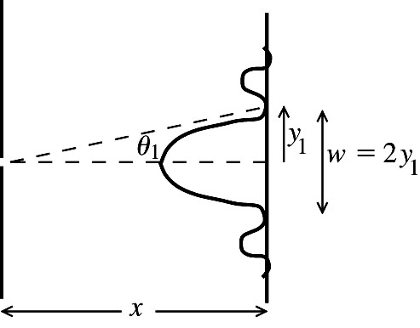 |  | Execute: The first minimum is located by
Figure 36.12a

(b) Set Up: The first bright fringe on one side of the central maximum is shown in Figure 36.12b.

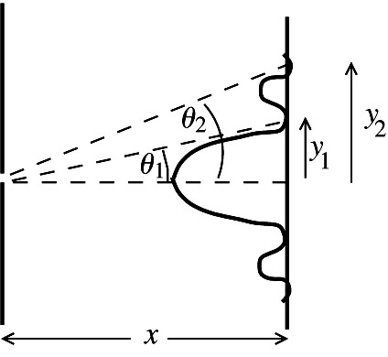 |  | Execute:
Figure 36.12b

Evaluate: The central bright fringe is twice as wide as the other bright fringes.

